FA042
How to Transport Goods Safely
Special application profiles require special housing technology
Author: Hendrik Thiel HEITEC AG, International Sales Manager Business Unit Electronics
Looking at the global development of the infrastructure in emerging industrial nations, growing data flow and market requirements as well as shorter time-to-market intervals and "just-in-time" adjustment to the production, the efficient transport of freight is becoming increasingly important. The different transportation concepts become more and more involved in the holistic value chains and the increased complexity of logistics, as all suppliers involved are confronted with ever evolving demands. In addition, more and more electronics is deployed in the transport sector to process the giant amount of data, to improve information management and communication, and to control the flow of goods and data. One example is rail freight, where subrack systems are used in harsh environments "on-track” and “off-track", i.e. "on" the train or "off" the train (in the signal box).There are - as for other regulated industries - special specifications and the systems need to meet higher requirements related to their mechanical stability and robustness, e.g. to withstand extreme temperature. They are rigorously tested for their suitability and must comply with EN 50 155 for electronic equipment in railway vehicles. This is because the reliability of electronics - and often the success of the whole project - to a large extent depend son the reliability of the mechanical components. The construction of the housing is based on the regulations in IEC 48D (DIN EN 60297-3x) of the International Technical Commission, which defines the mechanical structure and the dimensioning of the electronics as well as their compatibility and interoperability with the connected equipment.
HEITEC’s Ripac Vario Mobile subrack systems are precisely tailored to this mobile use and are vibration and shock tested in accordance with IEC 600-68-2-6 test Fc and IEC 600-68-2-27 Test Ea. This defines which test specifications must be met by components and equipment – e.g. in view of vibration damping or EMC sealing – when they are exposed to effects such as rotation, vibration, pressure or vibration in their respective working environment, e.g. in aircrafts, vehicles or trains. The aluminum subrack series Ripac Vario Mobile with its variable elements can be adapted exactly to the application requirements, either as self-contained systems, for installation in 19"cabinets or individually designed. They are available in different heights like 3U and 6U and are designed for card formats up to 220 mm depth. The scope of supply includes flanges, trim profiles, side panels, EMC clips, cover plates, mounting blocks, horizontal rails, tapped strips and insulating strips. The standard racks are delivered fully assembled, but may be equipped with different front panels, various ejector levers etc. upon request, depending on the requirements of the application, e.g. for EMC protection, cable layout, power supply, ventilation system, performance or number and connection of boards. So the specifics of the application can be considered at the earliest stage of development. The rear extension for backplanes and for connectors mounting is easy to accomplish. In this way the customer receives a complete, pre-certified modular system, which he can adapt quickly and cost-effectively to his individual application and optionally expand it at any time. This is made possible by the available accessories and in combination with the Ripac Vario housing family featuring identical horizontal rails and system components. As the name suggests, Ripac Vario can be variably targeted to EMC applications, complex conversions, mounting plates or mounting rails. The modular concept of Ripac subracks enables a maximum of possibilities with a minimum of components and easiest adaptation.
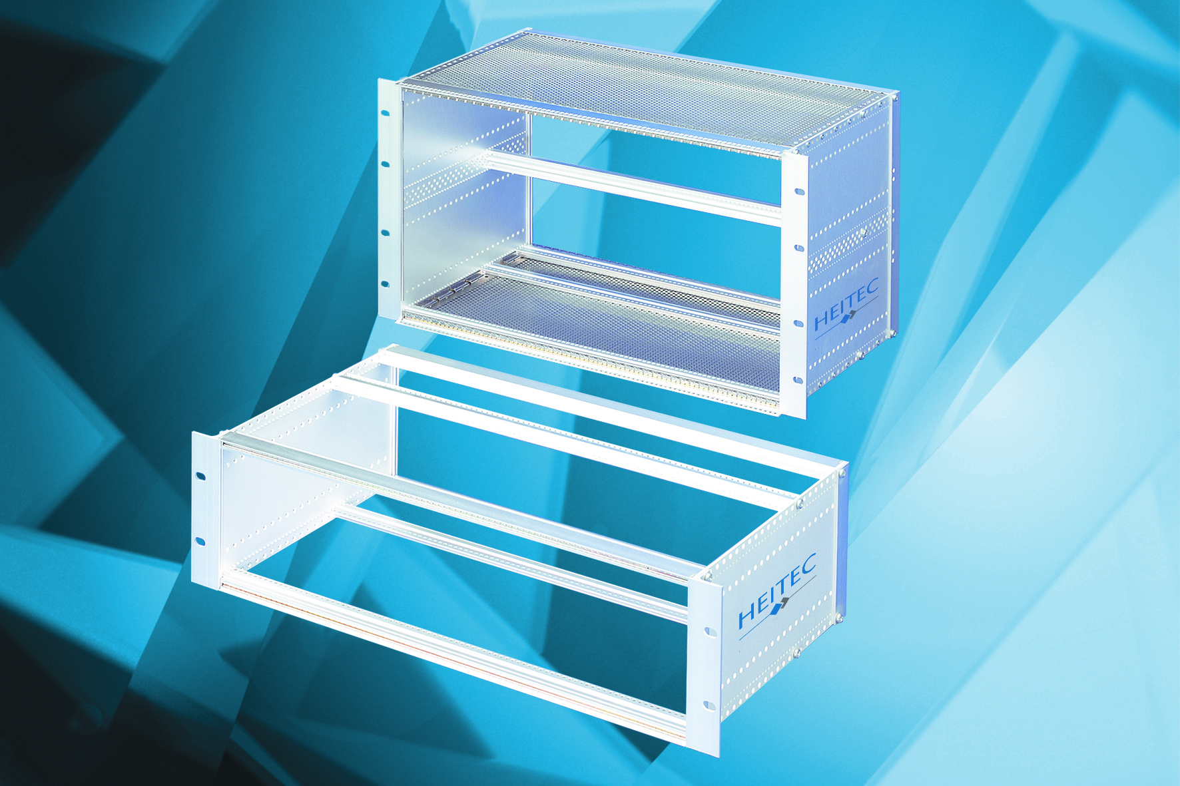

Caption: A modular system - the Ripac Vario Mobile subracks are available in different sizes.

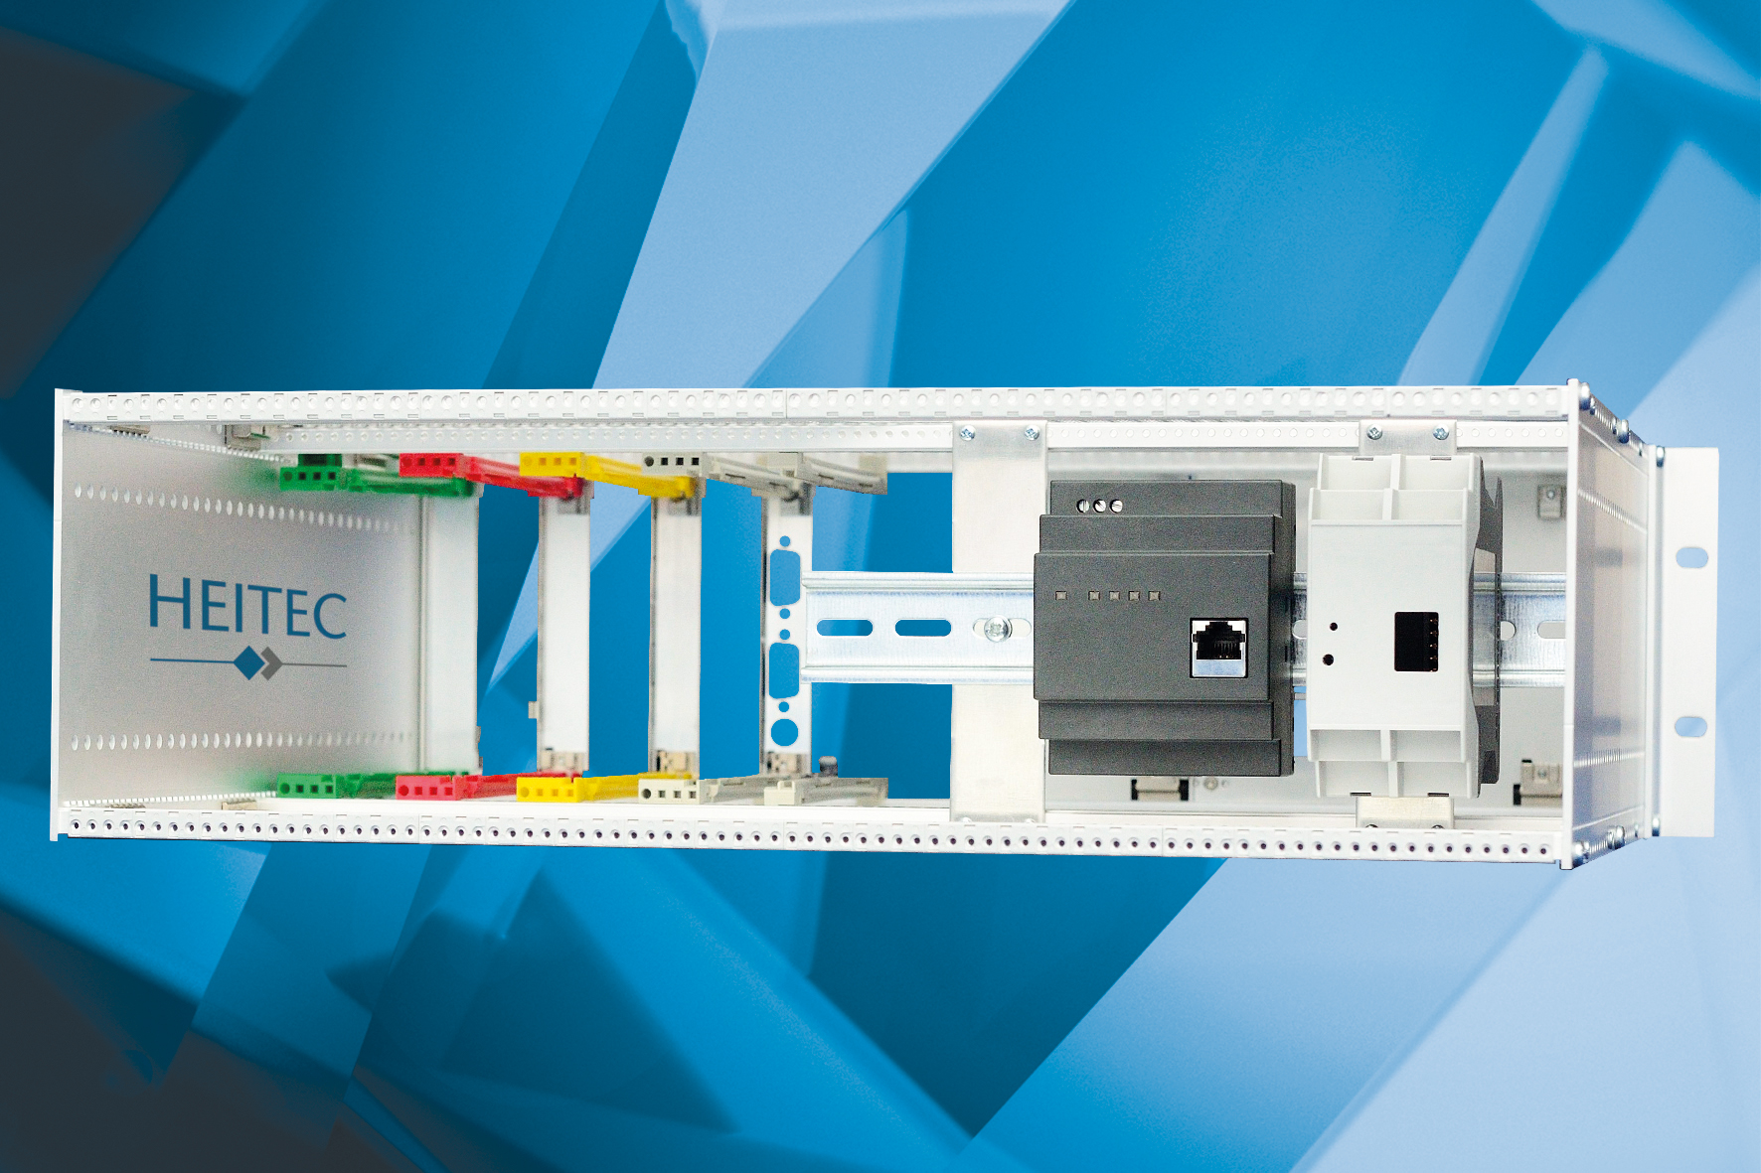


Hendrik Thiel, HEITEC AG, International Sales Manager Business Unit Electronics

HEITEC Corporate Profile
HEITEC represents industry expertise in automation and electronics and offers solutions, products and services in the field of software, mechanics and electronics.
In early 2013, HEITEC took over the complete electronics packaging systems line from RITTAL and with it, the development, manufacturing and sales of all standard articles and customer-specific solutions for Europe and worldwide.
Over 2000 customers increase their productivity and optimize their products with the help of HEITEC's state-of-the-art, reliable and economic system solutions.
A work force of 1000 employees at numerous sites worldwide provides high-quality industry skills close to the customer. More than 60% of HEITEC’s employees hold a graduate or postgraduate degree in technology.
During the last years HEITEC has grown substantially more than 10% – doubling its turnover within five years.
For more info: http://www.heitec-electronic.com

PCW Technology
Unit 11, Test Valley Industrial Estate
Nursling, Southampton
SO16 9JW

Telephone
02380 863764

